### Social Distancing Indicator and Alarming System

**A Project Report**

***Submitted by***

***Batch 6***

Shreyas Bhardwaj – 20171CSE0652

Shradha N – 20171CSE0645

Shreya G – 20171CSE0649

Shubham Sharma – 20171CSE0655

### *Under the guidance of*

**Mr. Prakash B Metre**

***in partial fulfilment for the award of the course***

***of***

***INTERNET OF THINGS***

# BACHELOR OF TECHNOLOGY

### IN

### COMPUTER SCIENCE

**At**



**Department of Computer Science and Engineering**

**School of Engineering**

**PRESIDENCY UNIVERSITY**

**BANGALORE**

**DECEMBER 2020**

**DEPARTMENT OF COMPUTER SCIENCE AND ENGINEERING**

**SCHOOL OF ENGINEERING**

**PRESIDENCY UNIVERSITY**

**CERTIFICATE**

This is to certified that the Project report **“Social Distancing Indicator and Alarming System”** being submitted by “**Shreyas Bhardwaj, Shreya G,** **Shubham Sharma and Shradha”** bearing roll number(s): 20171CSE0652, 20171CSE0649, 20171CSE0655 and 20171CSE0645, in partial fulfilment of requirement for the award of degree of **Bachelor of Technology** in **Computer Science and Engineering** is a Bonafede work carried out under my supervision.

|  |  |
| --- | --- |
| **Dr. Mohan K G**  HOD  Department of CSE  Presidency University | **Mr. Prakash B Metre &**  **Ms. Manasa C M**  Guide  Professor  Department of CSE |

**DEPARTMENT OF COMPUTER SCIENCE AND ENGINEERING**

**SCHOOL OF ENGINEERING**

**PRESIDENCY UNIVERSITY**

**DECLARATION**

I hereby declare that the work, which is being presented in the project report entitled “**Social Distancing Indicator And Alarming System”** in partial fulfilment for the course **“Internet of Things”** in award of Degree of **Bachelor of Technology** in **Computer Science and Engineering**, is a record of our own investigations carried under the guidance of  **Mr. Prakash B Metre and Ms. Manasa C M, Professor, Department of Computer Science and Engineering, School of Engineering, Presidency University, Bangalore.**

We have not submitted the matter presented in this report anywhere for the award of any other Degree.

# SHREYAS BHARDWAJ (20171CSE0652)

# SHUBHAM SHARMA (20171CSE0655)

# SHREYA G (20171CSE0649)

# SHRADHA N (20171CSE0645)

**ABSTRACT**

Due to the rapid growing need around the world to practice social distance, we have focused our project on using this application as an example for people. Many countries have introduced social distancing measures to slow the spread of the COVID-19 pandemic. Once the schools and offices reopen it will increase the risk of getting COVID-19. The only way we can decrease this risk is by maintaining social distancing. We started brainstorming on solutions through which we can make a device that not only maintains social distancing but is portable at the same time.

After a week of research, brainstorming and studying we came up with the idea to build a remote application that consists of an Arduino Uno which is connected with a buzzer, an ultrasonic sensor and a 9V Battery to power it and a Rocker Switch. The ultrasonic sensor calculates the distance between the person wearing it and people near him/her. If the person is not maintaining social distancing i.e. if the person is less than 6 feet apart then the buzzer will start buzzing and alert the person.

**TABLE OF CONTENTS**

|  |  |  |
| --- | --- | --- |
| 1 | Introduction | 5 |
| 2 | Requirements Analysis | 6 |
| 3 | Existing System | 10 |
| 4 | Proposed Work | 11 |
| 5 | Circuit Design | 12 |
| 6 | Implementation | 14 |
| 7 | Testing | 17 |
| 8 | Report | 19 |
| 9 | Conclusion | 23 |
| 10 | Enhancement | 24 |
| 11 | Bibliography | 25 |

**CHAPTER 1**

**INTRODUCTION**

The main objective of this mini project is to build an I0T based Social Distancing Indicator and Alarming System. The function of this application is to indicate the distance between the sensor and the object and send a warning signal through a Buzzer.

**Overview:**

The project **Social Distancing Indicator and Alarming System** is developed with the intension of controlling the spread of COVID-19 by using IOT tools to practice social distancing in an organized and safe manner.

**CHAPTER 2**

**REQUIREMENTS ANALYSIS**

**1 Introduction**

Since COVID-19 spreads from individual to individual, diminishing the manners in which individuals come in close contact with one another is fundamental. Social separating implies staying at home, however much as reasonably expected, and maintaining a strategic distance. From swarmed, open spots where close contact with others is likely, this is why remain at home requests are set up in such vast numbers of networks, dropping occasions and social affairs of more than ten individuals and shutting shops and cafés, and bars. Its likewise why numerous schools have moved to web-based learning. For essential excursions like shopping for food, the CDC suggests wearing a fabric face covering and remaining in any event 6 feet from others. Humane removal is a primary method to hinder the spread of COVID-19. Also, it's significant that you follow the common removing suggestions in your locale, regardless of whether you're in one of the high-hazard gatherings or not.

It may with schools shut and individuals telecommuting, it might be enticing to get kids together for playdates or sleepovers or to feel that social occasions of more than ten individuals are protected. In any case, social separating possibly works if we as a whole partake. Also, easing back down or forestalling the spread of the infection will spare lives. The spread of COVID-19 has been the fast and bureaucratic, state, and neighbourhood governments are doing whatever is essential to shield we all from becoming ill. While many people who become tainted will have indications like cold or seasonal influenza, and youngsters appear to be less influenced by the infection than grown-ups, we are liable for ensuring those at higher hazard. Steps like social removing may feel like a burden. However, it's the ideal way right presently to secure our family, companions, and neighbours who might be helpless. A coronavirus is a kind of typical infection that taints our upper respiratory tract framework, including throat and nose. It gets the name from its crown-like shape when watched under a magnifying instrument. According to the World Health Organization (WHO), pneumonia of obscure reason identified in Wuhan, China, was first answered to the WHO Country Office in China on 31st December 2019. The episode was proclaimed a Public Wellbeing Emergency of International Concern on 30th January 2020. On eleventh February 2020, WHO reported a name for the new coronavirus ailment: COVID-19. The circumstance was observed intently alongside day by day appraisal of the number of affirmed instances of COVID-19 over the globe.

According to the WHO report, in the previous fourteen days, the name of the cases of COVID-19 outside China had expanded 13-crease, and the quantity of influenced nations significantly increased. With more than 1,18,000 cases in 114 countries and 4,291 individuals who have lost their lives, COVID-19 was spreading alarmingly. In the resulting days and weeks ahead, it expected that the number of cases, the number of passing’s, and the quantity of influenced nations would increment further. Therefore, the WHO described COVID-19 as a pandemic. It spreads through the novel Corona Virus.

The number of people been infected with this deadly disease is increasing in India & the USA also. WHO has taken active steps intending to curb the spread of this disease?

As per an advisory issued the suspected patient should look for the following signs and symptoms:

• Fever

• Cough

• Shortness of breath or difficulty in breathing.

Presently there is no medicine to cure or vaccine to prevent COVID-19. As they say, prevention is better than cure, is aptly suitable in the current scenario.

The best ways to avoid infection is to get exposure to the virus through the following measures: • Observe good personal Hygiene

• Practice frequent hand washing with soap

• Covering mouth when coughing and sneezing

• Social Distancing.

As per Health Experts, Social Distancing can be an effective measure to curtail the spread of COVID-19. Social distancing is purposely maintaining the physical space between individuals to prevent the spread of illness. Keeping some distance of at least one meter from other people lessens the chances of getting infected with COVID-19. Social distancing is a prevention and control intervention implemented to decrease contact between those infected with a disease-causing pathogen and to slow down the rate and extent of disease transmission in a community. For the practical impact of social distancing, the authorities have also taken the following steps: • Work from home

• Closing of Educational Institutions and Coaching centres and shifting to online mode

• Maintaining in touch with near and dear ones using audio and video calls

• Annulling or deferring meetings, seminars and conferences.

There may be instances where people's movement or traveling is necessary to provide essential services like food, medicine, hospitals, banks, etc.

Social distancing in such scenario can be in the following manner:

• Keeping a distance of at least 1-1.5 meter between individuals

• Greet people with Namaste instead of handshakes

• Usage of electronic money instead of currency

• Avoid public transport Novel Economical Social Distancing Smart Device for Covid19

• Maintaining a distance of at least 1-1.5 meter while standing in a queue for shopping.

The individuals who are staying at home should take the following precautions:

• Wash hands frequently with soap

• Request visitors to avoid coming home

• Avoid visiting markets and shops for buying essentials and prefer the home delivery option

• Frequently sanitize surfaces like door knobs, taps, kitchen surfaces and other objects that are touched on a regular basis.

Technology will effectively be used for maintaining the requisite distance as per social distancing norms.

The proposed system uses a wearable device capable of sensing the distance between two individuals and triggering an alarm in the event of proximity between the individuals.

**1.1 Purpose**

This system addresses a general need to of knowing distance between two objects or generally two people through IOT components such as Arduino and Sensors, you learn the correct distance required to maintain according to WHO guidelines*.*

The main purpose of this project is to invoke confidence and a sense of duty among people by carrying around this device for not only their own safety but also the safety of others.

**2 Overall Description**

**2.1. Product Perspective**

Perspective of this project is to minimize human error and disobedience of people taking along a device which gives out a buzz sound when someone is close to the sensor based on the distance set which happens to be 6 feet according to WHO guidelines. Pairing this with other precautions the probability of catching this virus would be very less.

**2.2 Product Functions**

* Displaying colour according to the distance.
* Buzzer for instant reaction.
* Handheld or can be fixed around the wrist as a watch.

**2.3. Operating Environment**

**Software Requirements**

* Arduino Tinkercad
* Arduino IDE

**Hardware Requirements:**

* Arduino Uno Board
* Ultrasonic Distance Sensor
* 9V Battery
* Switch
* Buzzer
* Jumper wires

**3. Design:**

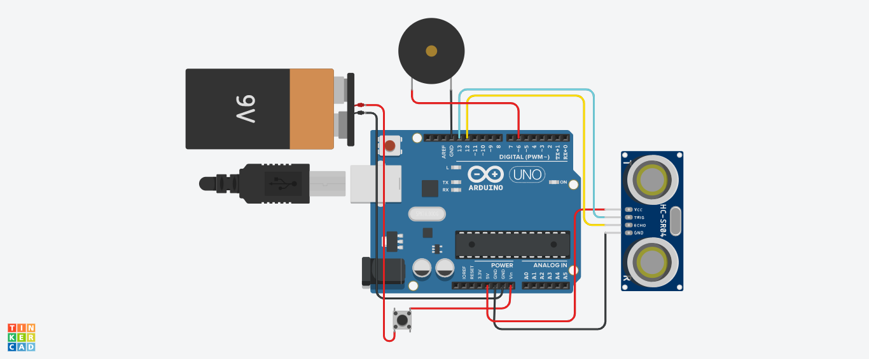

Figure1: Circuit Design

**3.1 Arduino Uno Board:** The **Arduino Uno** is an [open-source](https://en.wikipedia.org/wiki/Open-source) [microcontroller board](https://en.wikipedia.org/wiki/Microcontroller_board) based on the [Microchip](https://en.wikipedia.org/wiki/Microchip_Technology) [ATmega328P](https://en.wikipedia.org/wiki/ATmega328P) microcontroller and developed by [Arduino.cc](https://en.wikipedia.org/wiki/Arduino). The board is equipped with sets of digital and analog [input/output](https://en.wikipedia.org/wiki/Input/output) (I/O) pins that may be interfaced to various [expansion boards](https://en.wikipedia.org/wiki/Expansion_board) (shields) and other circuits.[]](https://en.wikipedia.org/wiki/Arduino_Uno#cite_note-Makerspace-1) The board has 14 digital I/O pins (six capable of [PWM](https://en.wikipedia.org/wiki/Pulse-width_modulation) output), 6 analog I/O pins, and is programmable with the [Arduino IDE](https://en.wikipedia.org/wiki/Arduino#Software) (Integrated Development Environment), via a type B [USB cable](https://en.wikipedia.org/wiki/USB_cable).

**3.2 9V Battery:** The nine-volt battery, or 9-volt battery, is a common size of battery that was introduced for the early transistor radios. It has a rectangular prism shape with rounded edges and a polarized snap connector at the top. This type is commonly used in walkie-talkies, clocks and smoke detectors but is being used here to power to the Arduino Board.

**3.3 Ultrasonic Distance Sensor:** As the name indicates, ultrasonic sensors measure distance by using ultrasonic waves. The sensor head emits an ultrasonic wave and receives the wave reflected back from the target. Ultrasonic Sensors measure the distance to the target by measuring the time between the emission and reception.

**3.4 Switch:** A switch is an electrical component that can disconnect or connect the conducting path in an electrical circuit, interrupting the electric current or diverting it from one conductor to another.

3.5 Buzzer: A buzzer or beeper is an audio signalling device, which may be mechanical, electromechanical, or piezoelectric (piezo for short). Typical uses of buzzers and beepers include alarm devices, timers, and confirmation of user input such as a mouse click or keystroke.

**3.6 Jumper wires:** A jump wire (also known as jumper wire, or jumper) is an [electrical wire](https://en.wikipedia.org/wiki/Electrical_wire), or group of them in a cable, with a connector or pin at each end (or sometimes without them – simply "tinned"), which is normally used to interconnect the components of a [breadboard](https://en.wikipedia.org/wiki/Breadboard) or other prototype or test circuit, internally or with other equipment or components, without soldering.

**CHAPTER 3**

**EXISTING SYSTEM**

Currently there is no official device such as this implemented anywhere by any organization even at this time which will make this device very important and crucial in this fight against COVID-19 and other such transmitted diseases.

* No technology being used in real time by general public other than awareness.
* It is difficult to maintain social distancing without such device and by using only our sub-consciousness.

**CHAPTER 4**

**PROPOSED WORK**

The main objective of this mini project is to build an I0T based Social Distancing Indicator and Alarming System. The function of this application is to indicate the distance between the sensor and the object and send a warning signal through a Buzzer.

.

As many of the factories and work places are not automated but rely on human power to get work done, having this device would be very beneficial in such cases.

The workers and other general public who will be using this device will be able to easily keep track of their surroundings and work done without having any sort of fear or hesitation.

Few functions are as follows

* Portable.
* Buzzer for instant reaction.
* Handheld or can be fixed around the wrist as a watch or can be fixed and worn like an ID-Card.

**CHAPTER 5**

**CIRCUIT DESIGN**

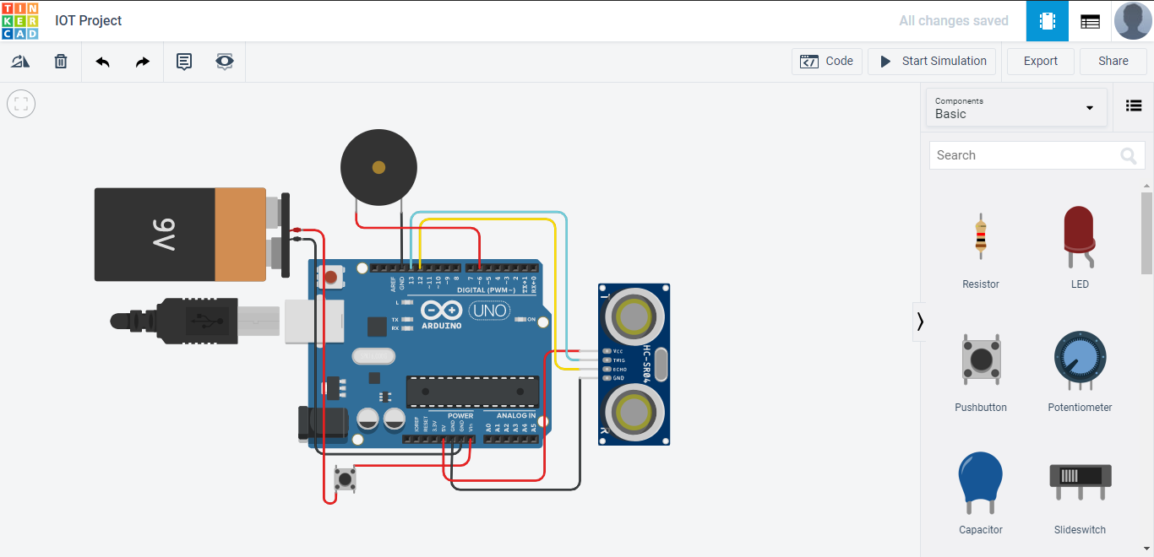Figure 2.1: Circuit Design without Simulation.

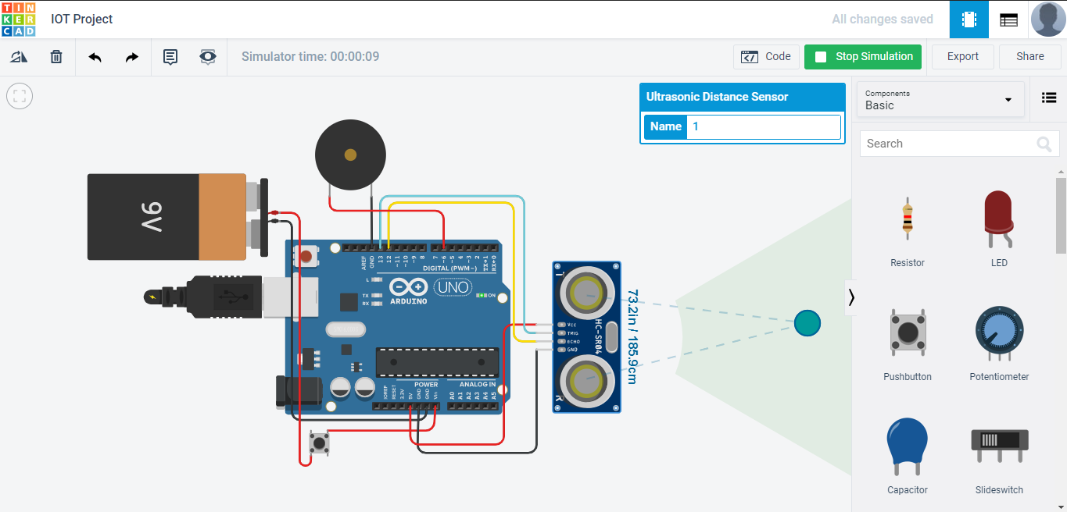

Figure 2.2: Circuit Design with Simulation and distance greather than 6 feet (Buzzer off).

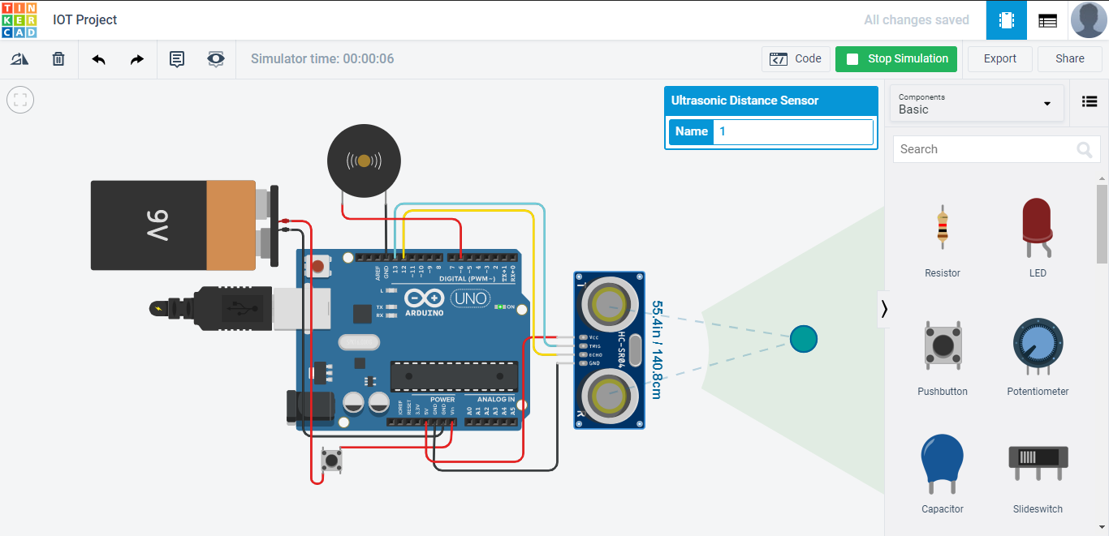

Figure 2.3: Circuit Design with Simulation and distance less than 6 feet (Buzzer On).

**CHAPTER 6**

**IMPLEMENTATION**

**Source Code:**

#define trigPin 13

#define echoPin 12

#define motor 7

#define buzzer 6

void setup()

{

pinMode(trigPin, OUTPUT);

pinMode(echoPin, INPUT);

pinMode(motor, OUTPUT);

pinMode(buzzer,OUTPUT);

}

void loop()

{

long duration, distance;

digitalWrite(trigPin, LOW);

delayMicroseconds(2);

digitalWrite(trigPin, HIGH);

delayMicroseconds(10);

digitalWrite(trigPin, LOW);

duration = pulseIn(echoPin, HIGH);

distance = (duration/2) / 29.1;

if (distance < 183) // This is where checking the distance you can change the value

{

digitalWrite(motor,HIGH); // When the the distance below 6 feet

digitalWrite(buzzer,HIGH);

} else

{

digitalWrite(motor,LOW); // when greater than 6 feet

digitalWrite(buzzer,LOW);

} delay(500);

}

**Connections:**

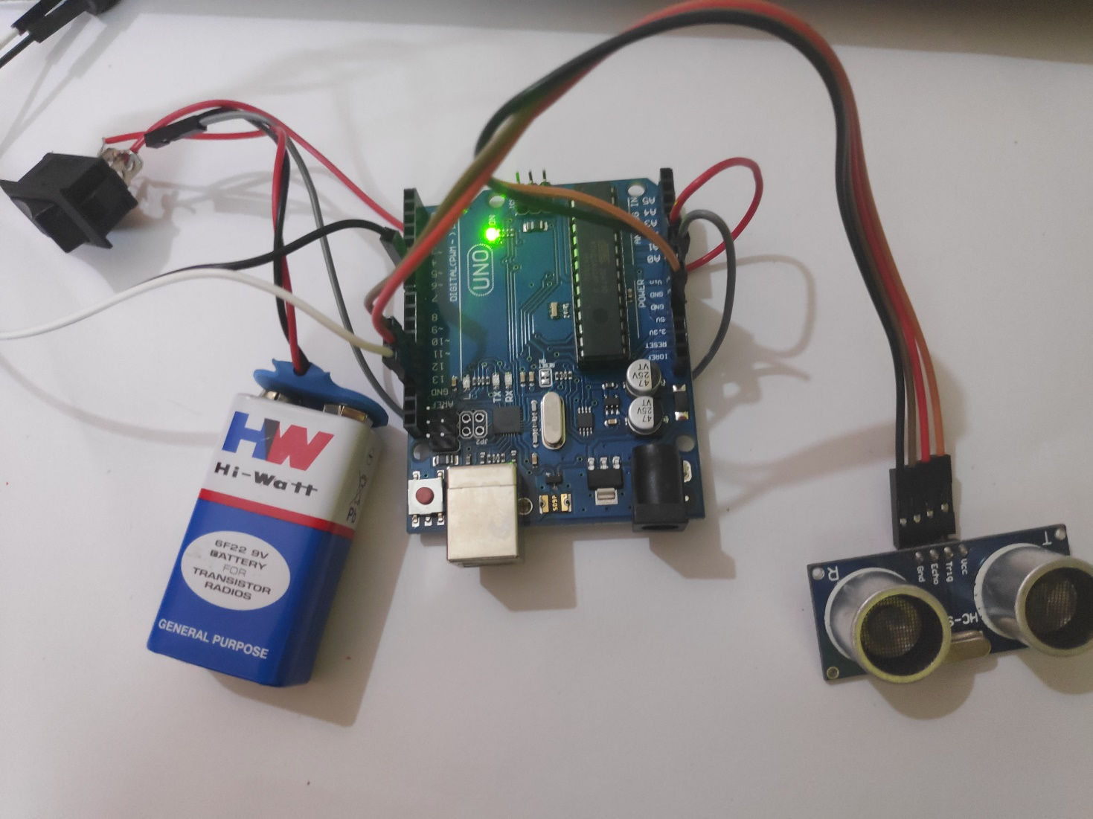

**CHAPTER 7**

**TESTING**

**Test approach**:

We will test the project in two stages: software and hardware. The software part is to be tested via the Arduino IDE, whereas the hardware part has to be tested physically. It is necessary to check whether the system is working properly or not. To check whether the readings are accurate, we will check the distance pointed out by the sensor by a meter tape.

**Features to be tested:**

After building the whole circuit we test it. This project should satisfy some features.

Features to be tested as follows:

* The ultrasonic sensor should give proper output. To check whether the output is accurate

or not, the output of the sensor will be checked against a meter tape

* The Buzzer should turn on only when the distance is less than 6 feet or else it should automatically be off.
* Arduino should be powered on only when the switch connected to the battery is on.

**Testing tools and environment:**

For testing of the project, we require some tools, like to test Arduino program we require a software called Arduino IDE. Using this we can check the program that program is working properly or not. For hardware checking we require power supply and proper range of measurements and a meter tape.

**Test cases:**

In this section we discuss about the inputs, expected output, testing procedure.

**Inputs:**

This project requires two inputs:

1. Power supply: Power supply is the basic need of any electronic circuit. Here we use a 9v battery to give power Arduino and sometimes we can give power directly from the computer.

2. Switch: The switch can be connected in between the battery and the Arduino to control the power supply.

**Expected output:**

The expected output of this project should be a buzzer sound according to the distance reading which is taken from the ultrasonic sensor i.e., if less or more than 6 feet the buzzer turns on and off respectively.

**Testing procedure:**

For testing, the circuit is first connected to the computer and power supply is given to the Arduino using computer which can also be done by using a battery. In this way the whole testing circuit is built. Now we give input to the HC-SR04 by changing the distance of an object in front of the sensor and checking the reading of the length by using a meter tape.

Summary of testing procedure:

1) Connect the circuit according to the diagram

2) Give power to the Arduino by turning on the switch.

3) Vary the distance between the sensor and the object in front of it for the ultrasonic sensor to give output.

4) Check the buzzer sound according to the distance.

5) Confirm that the buzzer turns on only when the distance is less than 6 feet and automatically turns off otherwise.

**CHAPTER 8**

**REPORT**

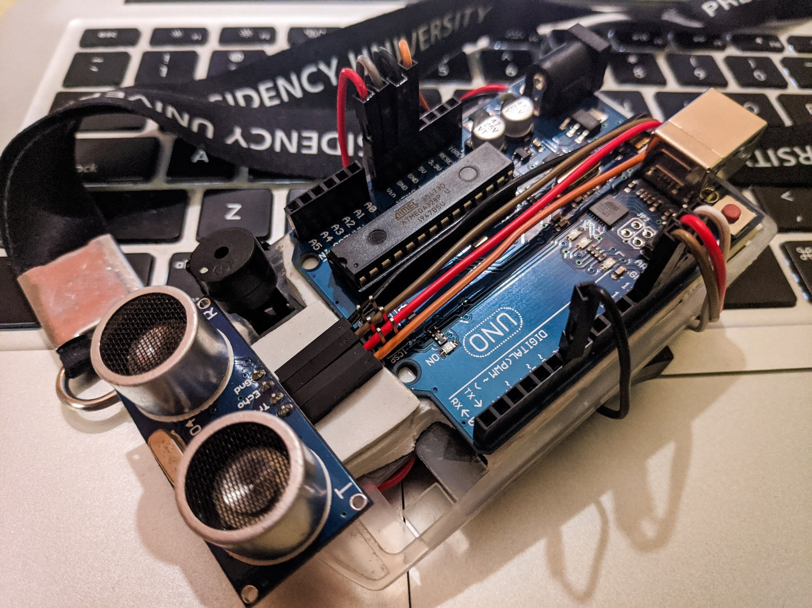

Figure 3.1: Final Product Image.

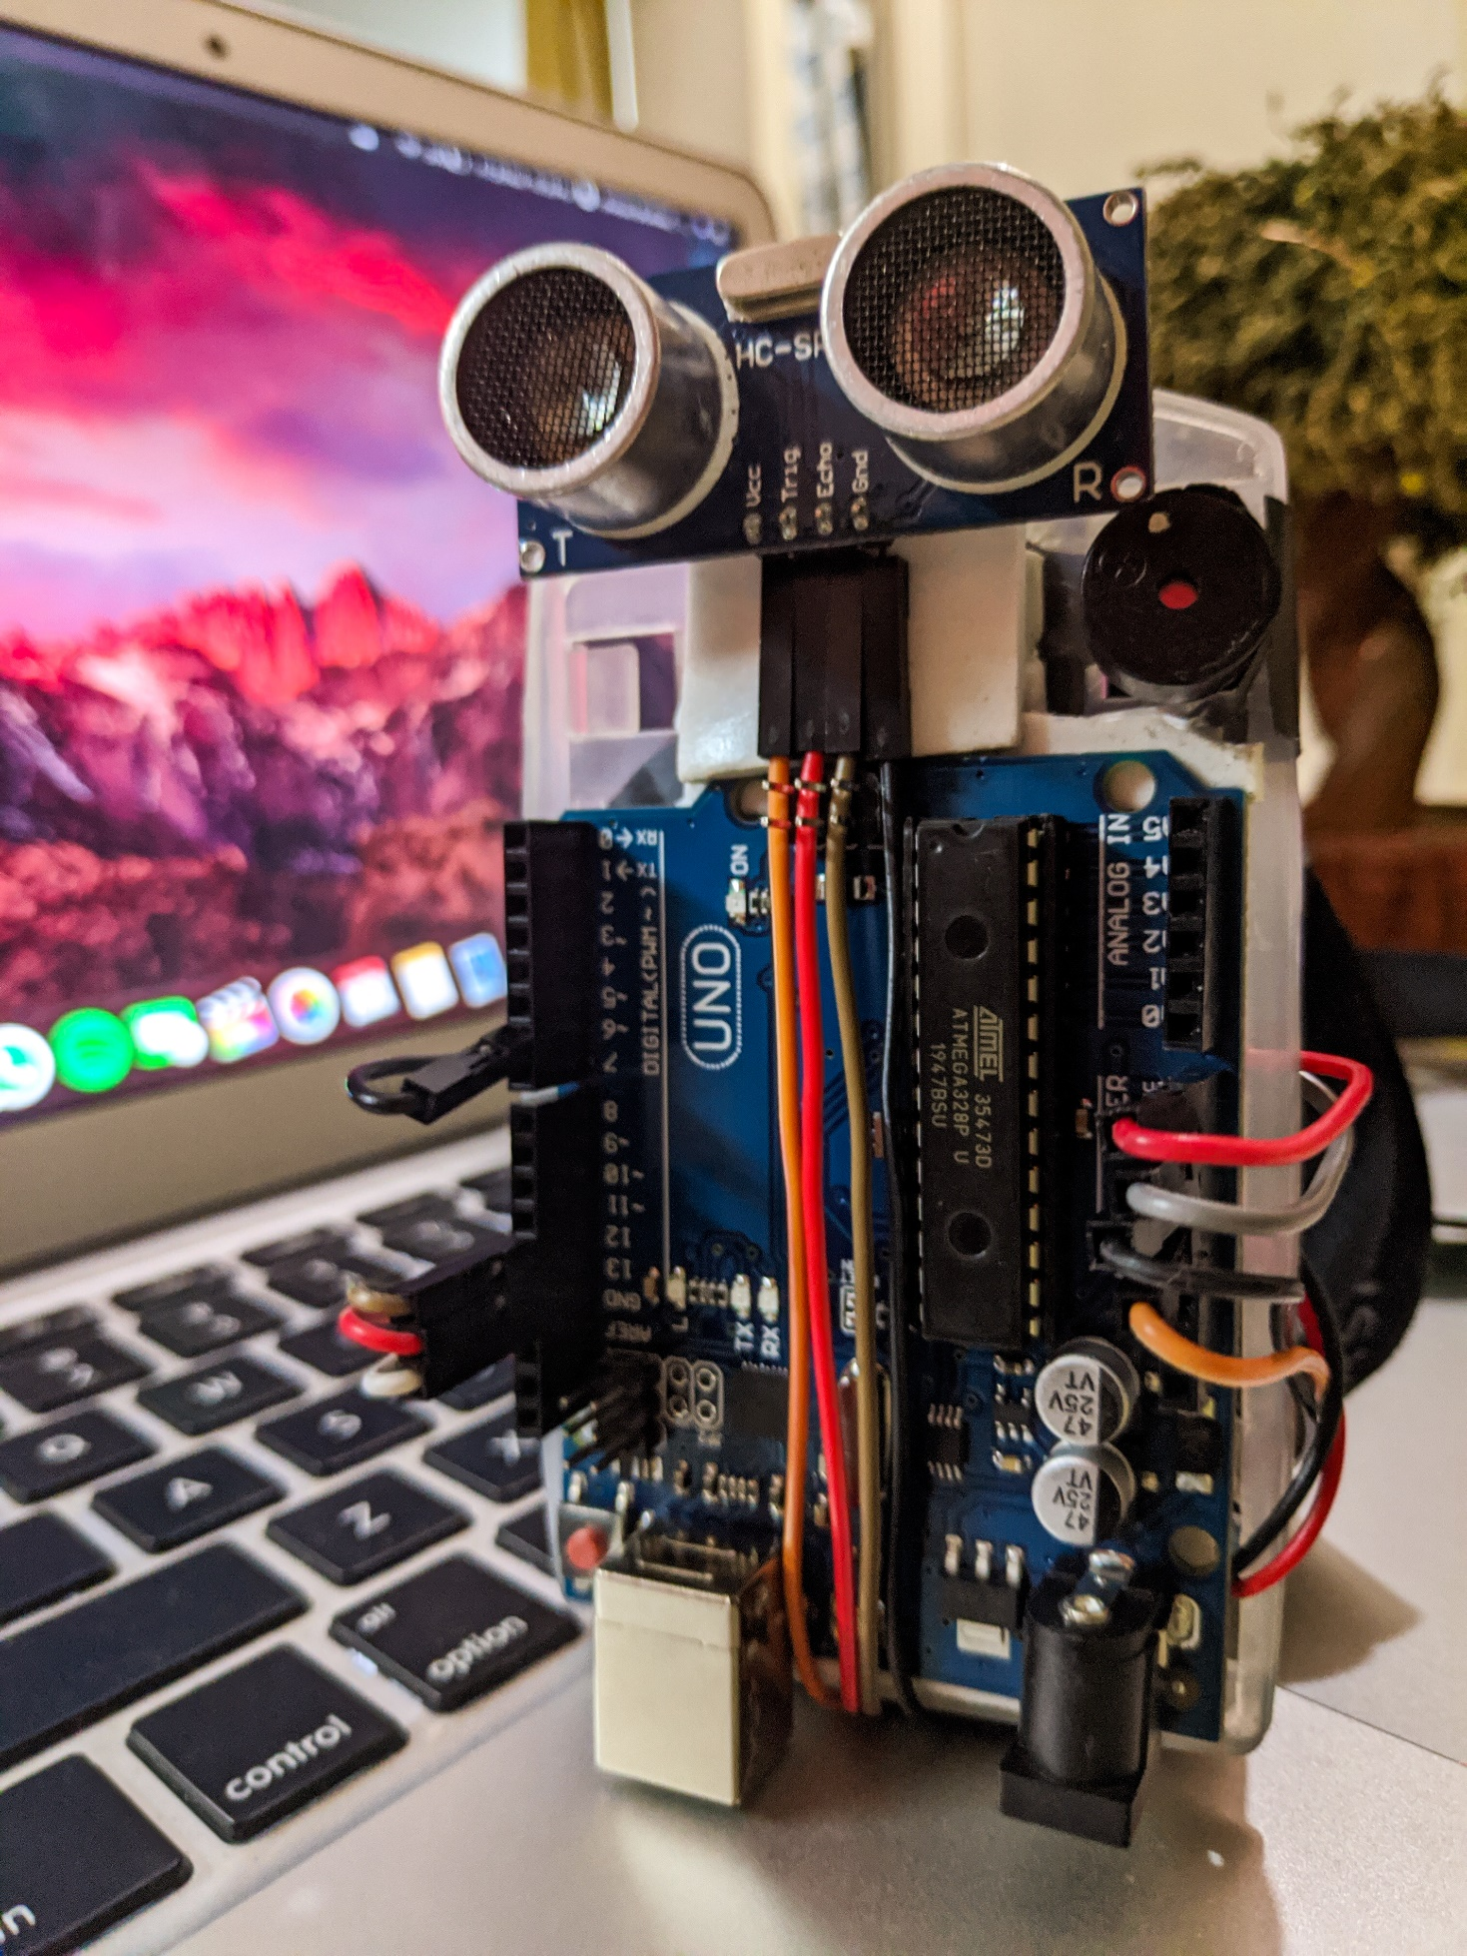

Figure 3.2: Final Product Image.

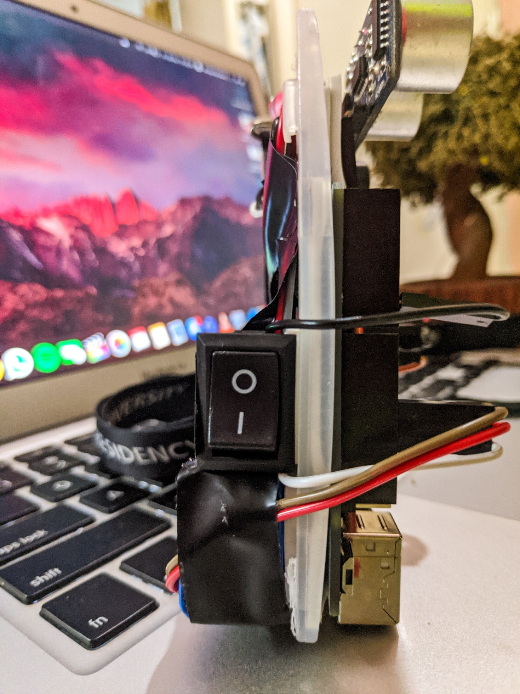

Figure 3.3: Final Product Image.

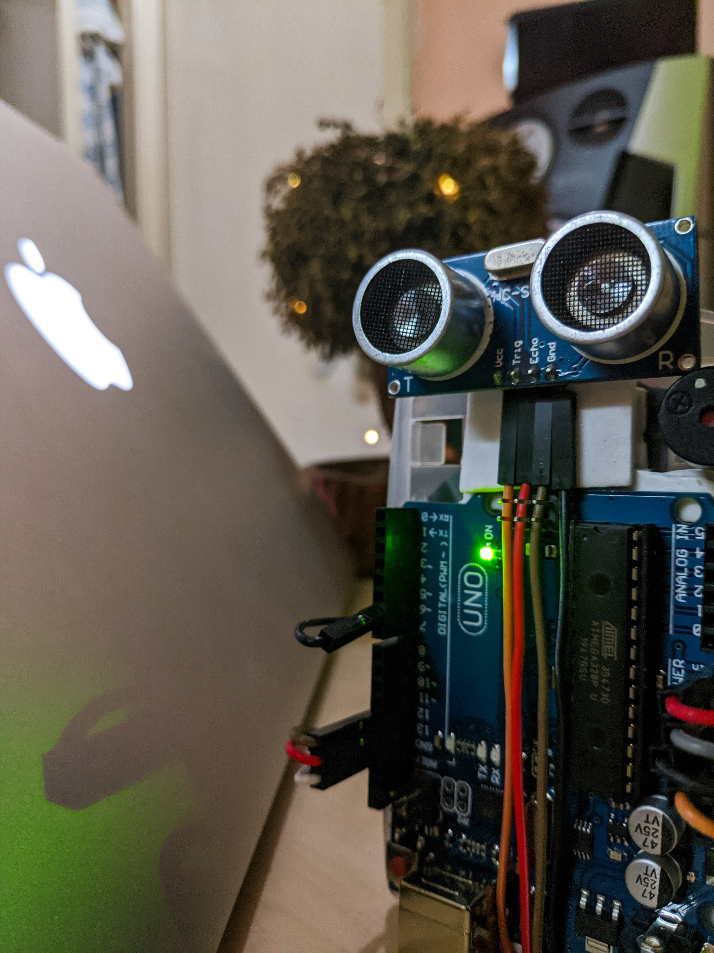

Figure 3.4: Final Product Image (Switched ON).

**CHAPTER 9**

**CONCLUSION**

In conclusion, this product is a crucial tool in today’s world and thus every factory, college and general public should make us of it.

Our Social Distance Indicator and Alarming System was successful in the making and our goal which was to remind people about the necessary precautions for COVID-19 through technology was also satisfied.

**Problem and how we fixed it:**

In our prototype, the ultrasonic sensor was always on and so was the Buzzer. The Arduino Uno was directly connected to a battery which gave it a constant supply because of which it was always on.

We couldn't keep the device always on so we decided to add a rocket switch. Like this, if you want to turn your device off you can do so just by using the switch.

**Future scope and further enhancement of system**

The project has covered almost all the requirements. Further requirements and improvements can easily be done since the coding is mainly structured or modular in nature as well as the components are all easy to find.

Further the device can also be improved by:

* 1. Using Arduino Nano instead of Arduino Uno so that the device is even smaller and hence more portable.
  2. Adding an RGB LED or a Vibration Sensor for loud environments where the buzzer sound might not be audible.
  3. Product design could be made better which better cable management and overall design.
  4. Charging Module can be added to charge the Battery for further long-time use.

**Bibliography**

1. Internet of Things “A hands on approach” Authors: Arshdeep Bagha, Vijay Madisetti

Publisher: Universities Press 2015.

2. The Internet of Things “Connecting Objects to web” Authors: Hakima Chaouchi

Publisher: Wiley 2017.

3. <https://www.arduino.cc/>